1. Webpage Template [5]
Use DreamWeaver to create New Document > Blank Template > HTML Template > 1 column fixed, centered, header and footer.
DocType: HTML 5
Layout CSS: Create New File
Save As: Temp-ClassName-StudentName.dwt
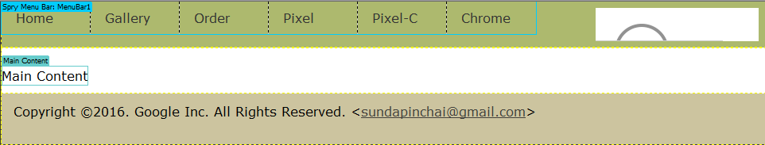
Menu: Spry Menu Bar > Horizontal (2)
Home links to index.html
Gallery links to gallery.html
Order links to order.html
Pixel links to gallery.html#phone
Pixel-C links to gallery.html#tablet
Chrome links to gallery.html#laptop

Background color: #ADB96E when the mouse is out.
#C6D580 when the mouse is hover, focus or visible.
Search Box: font size: 18 pixels; width=160 pixels with stretching animation when the mouse focuses on. (1)

Editable Region: Main Content inside <div class=”content”> (0.5)
Footer: Copyright info, full name, email link. (0.5)
Scroll-to-Top link is on the right of the footer. This link displays only when the user scrolls down to the bottom of web page. If the user clicks on it, the web page scrolls to top. (1)

2. Home Page [1.5]
Create a New Document > Page from Template > Temp-ClassName-StudentName.dwt. Then save as: index.html
Insert text and video:

3. Gallery [4.5]
Create a New Document > Page from Template > Temp-ClassName-StudentName.dwt. Then save as gallery.html
Create an automated slide, audio player, product info text.
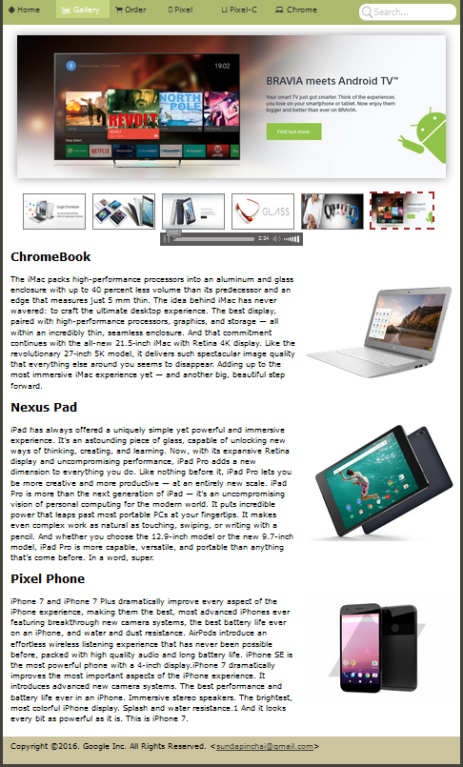

3. Order [7]
Create a New Document > Page from Template > Temp-ClassName-StudentName.dwt. Then save as order.html
Create an order form:
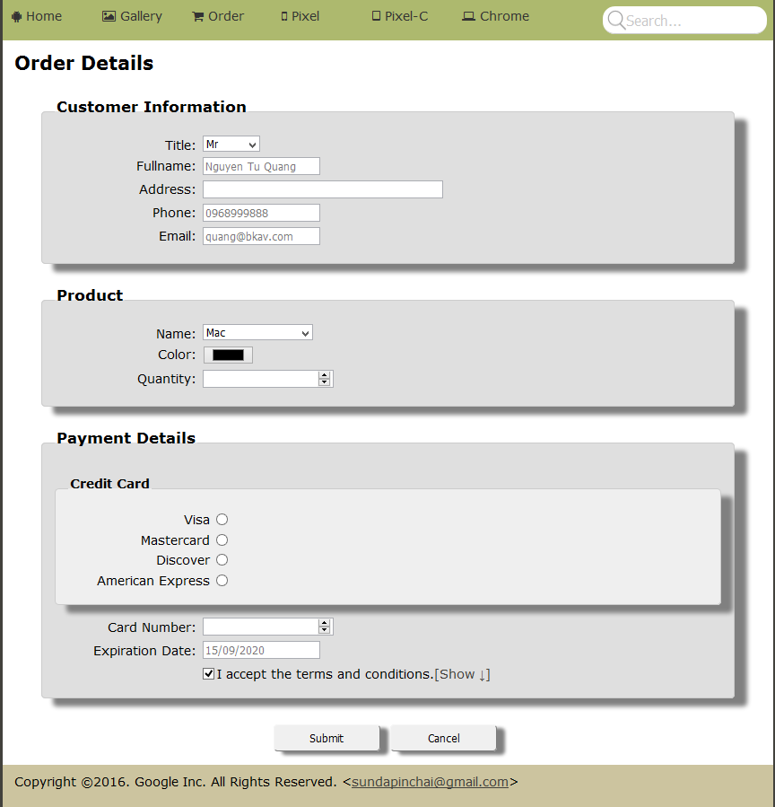
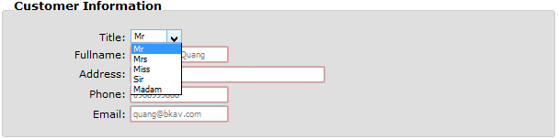


Form Validation
Field | Validation
Fullname | required
Address | required
Email | required  placeholder="billgate@gmail.com"  title=”Email must be valid!”  pattern=”^[a-zA-Z0-9_.+-]+@[a-zA-Z0-9-]+\.[a-zA-Z0-9-.]+$”
Phone | required  title=”Phone number must have 10 digits!”  pattern=”^[0-9]{10}$”
Product
Quantity | required  min=”1” max=”10”
Credit Card | required
Card Number | required  pattern="^[0-9]$"
Expiration Date | required  title="Date time must be valid! (dd/mm/yyyy or dd-mm-yyyy or dd.mm.yyyy)"  pattern="(0[1-9]|[12][0-9]|3[01])[-/.](0[1-9]|1[012])[- /.](19|20)\d\d"  placeholder="30/04/1975"
I accept terms and conditions | required.

When user clicks the button Cancel, all of the form’s details must be reset to the beginning state.

When user clicks the button Submit, validate the form using html5 attributes (and javascript if needed).
If the form is valid, it is then submitted to the next page named contact.html designed as below:
